Trey Causey

This is screen shots of my working program.
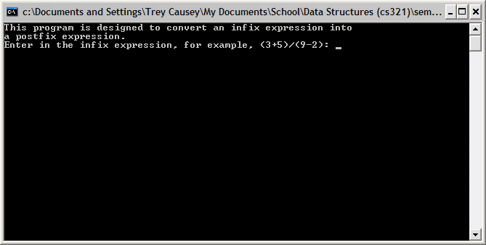

After input, it is:
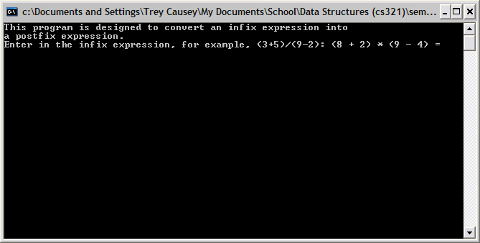

After pressing enter:
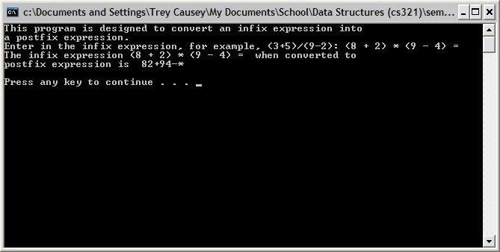

There has been no modification to the program since it has been turned in.

